Psychology Crash Course #1: Intro to Psychology (Modules 1-3)

Psychology:
Original Latin Definition:

Current Definition:

Contributors to Psychology:
Aristotle:

Chinese Rulers and the First Psychological Exam:

Persian Razes:

Psychology today is about tacking the big questions such as:
- How can humans commit genocide or torture other humans?
- Do we have free will, or are we driven by our environment, biology, and nonconscious influences?
- What is mental illness, and what can we do about it?
- What is consciousness or the notion of self?

The most influential and controversial psychologist was _______________________________.

The early schools of psychological thought: Later schools added:
Structuralism Psychodynamic
Functionalism Humanistic
Psychoanalysis Cognitive
Behavioral

**1879- the first psychology lab was set up by _________________________________________.
- His student was ____________________________________
- Arguments:
- Tried to understand the structure of a person, asking them to look inward known as ________________________________ and relied on introspection.
- Problems:
**In response to the problems of Structuralism, _______________________________ proposed a different set of questions looking at the why do we do things.
- Functionalism was inspired by ________________________
- His definition of psychology as:

**Freud- started as a medical doctor specializing in _____________________________
- Watched __________________ treat Anna O with a new talking cure. Describe this talking cure:
- Freud encouraged ____________________________.
- 1900 Freud introduced his theory of _________________________
  - Personalities are shaped by unconscious motives
  - We are affected by mental processes that we are not aware of
  - The subconscious is discoverable through the use of ________________, projections, and free association to root out repressed feelings and gain self- insight.
  - Mental illnesses can be healed through _________________________
**Ivan Pavlov and John B Watson, BF Skinner- school of thought __________________________________
- Focus on the study of ___________________________________________________-
**The descendants of Freud and psychoanalysis became known as ______________________________________
- Focused on the early experiences shaping the _________________________________ and how that process shapes our thoughts, feelings, and personalities
Other perspectives that we will talk about this year:
Humanistic Psychology
Cognitive Psychology

Psychology today recognizes the need to study observable and recoding behavior and also gives credit to the mental process of what we feel and believe.

Psychology is an integrated science! It asks interesting questions, and attempts to answer them through all kinds of data-gathering methods.
The human brain is by far the most complex object known to us in the entire cosmos.

Psychology Crash Course #2- Research and Experimentation (Modules 4-8)
- Explain hindsight bias.

- How is a theory different from a “hunch”?

- Once you have your theory and hypothesis in place, what’s the next step?

- Why is replication of a study so important?

- What is a case study?

- Why can case studies sometimes be misleading?

- What are some of the pros of case studies?

- What is naturalistic observation?

- What are the pros and cons of naturalistic observation?

- What would a survey likely be used for?

- Why is word choice in a survey/interview so important?

- How would one get a representative sample?

- What is correlation?

- Correlation is NOT causation. Explain this statement.

- Correlations predict the _____________________________ of cause-and-effect relationships, but they cannot ____________________________ them.

- What is the purpose of an experiment in psychology?

- Define Experimental Group-

- Define Control Group-

- Define placebo-

- Define double-blind procedure-

- Define independent variable-

- Define dependent variable-

- Why is it important to get informed consent?
Psychology Crash Course: # 3 - The Chemical Mind (Modules 9-10)
EVERYTHING PSYCHOLOGICAL IS BIOLOGIAL
- What is a neuron?
- The basic parts of the neuron:
  - Cell body-
  - Dendrites-
  - Axon-
  - Myelin Sheath-
  - Synapse-
  - Synaptic Cleft-

- What do neurotransmitters do?

- There are two different types of neurons: excitatory and inhibitory neurons. What is the difference and give some examples.

- The endocrine system is responsible for the release of hormones. Given some examples of areas where hormones are needed.

- Name four glands that make up the endocrine system and state their purpose.

- Which gland is the master gland?

Psych Crash Course: # 4 Know Your Brain (Modules 11-15)
- What is phrenology? Why did this science fall out of fashion?

- Different parts of the ________________________ control different aspects of our _________________.
- What is the CNS?
- What is the PNS?
- Who is Phineas Gage and why is he so important to psychology?

Brain Parts.
- The Old Brain: The parts that many animal species also have
  - Brain Stem:
  - Medulla:
  - Pons:
  - Thalamus:
  - Reticular Formation:
  - Cerebellum:
- Limbic System:
  - Amygdala:
  - Hypothalamus:
  - Hippocampus:
- Corpus Callosum:
- Cerebral Cortex:
- Glial Cells and fissures:
- Lobes:
  - Frontal:
  - Parietal:
  - Occipital:
  - Temporal:

Psychology Crash Course #5 - Sensation and Perception (Modules 16-17)
Name __________________________________________________________
- What condition does Oliver Sacks have?
- Define:
  - Sensation
  - Perception
  - Absolute Threshold of Sensation
  - Signal Detection Theory
  - Sensory Adaptation
  - Difference Threshold/Weber’s Law
- Place a number on the line in the order of how light comes into your eye.
  - _______ Fovea
  - _______ Cornea
  - _______ Bipolar Cells
  - _______ Optic Nerve
  - _______ Pupil
  - _______ Ganglion Cells
  - _______ Iris
  - _______ Retina
  - _______ Thalamus
  - _______ Lens
  - _______ Rods and Cones
  - _______ Occipital Lobe
- Wavelengths- Using crayons, trace the wavelengths to show the appropriate colors.
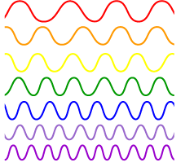
- Amplitude tells us ________________ of color and sounds.
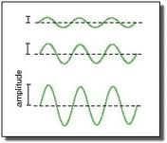

- Define:
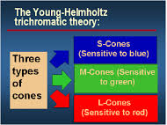
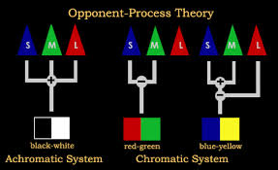
Crash Course Psychology #6: Homunculus (Modules 20 – 21)
- Draw a homunculus
- Identify the difference between sensation and perception.
- Sounds move in _______________.
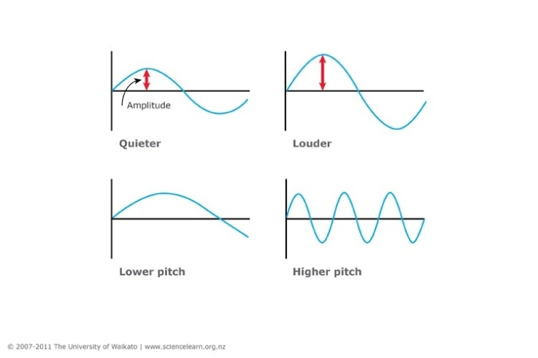
- What is directional stereophonic hearing?

- Number the order of the ear parts that are activated when sounds enter your ear.
  - _______ Inner Ear
  - _______ Ear Drum
  - _______ Anvil
  - _______ Stirrup
  - _______ Outer Ear
  - _______ Hammer
  - _______ Cochlea
  - _______ Auditory Cortex
  - _______ Middle Ear
  - _______ Cochlear hair Cells
  - _______ Auditory Nerve
- Name the five tastes.

- What is synesthesia?

- What are the two types of chemical senses?

- How we __________ about a smell, and our ________________ of it, is often tangled up in our ________________ with that scent.
- Why are scents linked to memories?
- How does touch (or lack of touch) affect development in animal and human babies?
- What four senses make up the sense of touch?
- Define:
  - Kinesthesis
  - Vestibular sense

Crash Course Psychology #7 - Perceiving is Believing (Module 17)
- What is perception?
- What is a perceptual set?
Seeing is believing and believing is seeing.
- How does each of the following help understand what you see?
  - Context:
  - Culture:
- Form Perception:
  - Figure Ground
  - Proximity
  - Continuity
  - Closure
- Label the diagrams below with the above words (a-d only)
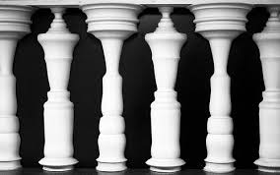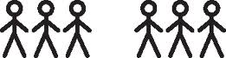
- Seeing depth:
  - Binocular cues:
  - Monocular cues:
    - Relative Size and Height:

    - Linear Perspective
    - Texture Gradient
    - Interposition
  - Label the pictures below (i-iv only):
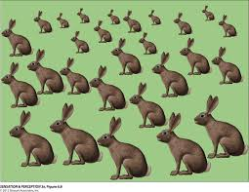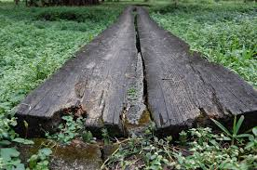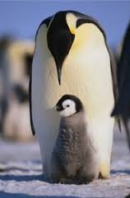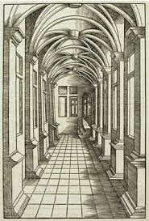
- Motion Perception:
  - _____________________ objects are _______________ and enlarging objects are _________________
  - Large objects move much more ____________________ than small objects going the same speed.
  - Your brain constructions your _____________________.

Psychology Crash Course #8 - States of Consciousness (Modules 22-25)

Loosely define consciousness:

Who is William James?

What are the main states of consciousness that we all experience?

In the field of cognitive neuroscience, how is the brain studied?
- Structural Imaging
- Functional Imaging

What is dual processing?

Module 16:
Selective Attention:

- Cocktail Party Effect:

Selective Inattention:
- Inattentional Blindness:

- 50% didn’t notice the _____________________.

- Misdirection:

- Change Blindness:

Psychology Crash Course #9 - To Sleep, Perchance to Dream (Modules 23-24)

What is sleep?

We spend about a quarter of our lives sleeping. (True or False)

List three reasons why science thinks we sleep.
- Q
- Q
- Q

What is an EEG machine? How does it relate to sleep?

What is REM sleep?

What are the four stages of sleep?
- W
- W
- W
- W

The hormone _______________________ gets you ready for sleep.
The stages of sleep:
- NREM 1

- NREM 2
- NREM 3
- REM
Each sleep cycle lasts about _________________ minutes before repeating again.

If someone experiences a lack of sleep, what can the consequences be?

Sleep Disorders:
- Insomnia
- Narcolepsy
- Apnea
- REM Sleep Disorder
- Night Terrors
- Nightmares

Why do we dream?

Dreams tend to be about your day. (true or false)

What is Oneirology?

Wish Fulfillment:

Information Processing Theory:

Cognitive Development:

Random Neural Firings:

Crash Course Psychology #10 - Altered States
What is hypnosis?

Who is Franz Mesmer?

Define Consciousness (again):

Hypnosis:
Used for:

Hypnosis can’t make you act ______________________________________________.

Hypnosis can be used to get at your deeply buried memories. (true or false)

What is the Social Influence Theory?

What is Dissociation?

Drugs:
What is tolerance?

What is neuroadaption?

The three types of drugs:
Depressants:

Stimulants:

Hallucinogens:

Psych Crash Course #11 - How to Train a Brain (Learning) Modules 26-29)

- Who is Ivan Pavlov?

Behaviorism

Define learning:

*learning helps organisms adapt and survive

Associative Learning:
* the most basic form of learning

Before Conditioning:
an Unconditioned Stimulus elicits a natural response

food-----------> slobber

After conditioning
a Neutral Stimulus can lead to the natural response

bell ---------> slobber

**this is known as Classical Conditioning**
Shows how a process like learning can actually be studied through direct observation

Behaviorism:
BF Skinner and John Watson

Why is Watson and his studies so controversial today?

Operant Conditioning:

**give an example of operant conditioning:

Behaviors increase when followed by ___________________; behaviors decrease when followed by ______________________.

Reinforcement | Positive Reinforcement | Negative Reinforcement
Punishment | Positive Punishment | Negative Punishment

Shaping:

Successive Approximation:

Primary Reinforcer:

Conditioned Reinforcer:

Reinforcement Schedules:

Extinction:

Partial Reinforcement:

Intermittent Reinforcement:

Psych Crash Course #12 - Bobo Beat Down- Social- Cognitive Learning (Module 30)

Who is Bobo?

Who is Albert Bandura? What is he studying?

What is the basic idea of his study with Bobo?

What happened when a child watched an adult beat Bobo?

What happened when a saw an adult play nice with Bobo?

Learning is solely about conditioning and association with rewards and punishment. (True/false)

Learning can occur through ________________ and _________________ someone else's behavior.

What is associative learning?

classical conditioning

operant conditioning

learning

**We are more _________________________ than we are sight or sound adverse.**

Species can more _______________ learn associations that help them thrive or survive, and that not all associations are learned equally.

It is much easier to.....
  - Teach a pigeon to peck an X on the ground because

- Teach a pigeon to flap its wings to avoid an electric shock because

What we learn doesn't only influence our behavior, it also ________________ our attitudes.

Cognition:

Latent learning:

Cognitive maps:

Observational learning:

Shaping:

"Imitation is not just the sincerest form of flattery--it's the sincerest form of learning."

Psych Crash Course #13: How We Make Memories (Modules 31-32)
- Define Memory-
- List three ways we can retrieve memories. Define them.
- List the three stages of memory.

- Short Term Memory (STM) lasts only about _____ seconds and can hold only ___________ items.
- Long Term Memory (LTM): How can we get information into LTM?
  - Procedural Memory-
  - Episodic Memory-
  - Mnemonics-
  - Chunking-
  - Shallow processing v Deep processing-
- What is working memory?
- What is the difference between explicit memory and implicit memory?

Psych Crash Course #14: Remembering and Forgetting (Modules 33)
- What is a retrieval cue?
- Explain the following retrieval cues:
  - Priming-
  - Context Dependent Cue-
  - State Dependent/Mood Congruent Cue-
  - Order Dependent Cue-
    - Serial Position Effect:
    - Primary Effect:
    - Recency Effect:
- What are the three reasons for forgetting?

- What we fail to notice, we tend not to encode, and this do not remember.
- Something things interfere with our learning. What are the following:
  - Proactive Interference-
  - Retroactive Interference-
  - Misinformation Effect-
  - Source Attribution-
- Memory is both a reconstruction and a reproduction of past events.

Psych Crash Course #15: How Your Mind Can Amaze and Betray You (Modules 34-35)

- Review: Define Cognition-
- List the five parts of cognition:

- What is a concept? (They simplify ideas)
- We organize concepts by forming _____________________. Define:
- Our cognition works to our benefit through our ability to solve problems.
- To solve problems we usually try trial and error. We can also use:
  - Algorithm:
  - Heuristics:
  - Ah-ha moments:
- Cognition is not always right:
  - Confirmation bias:
  - Belief Perseverance:
  - Mental set:
  - Functional Fixedness:
- People believe that an event will be more likely to occur if they can conjure up examples or memories of it. If something is vivid, scary, in recent memory, or awesome, you will think it happens more often than it really does.
  - Availability heuristic:
  - Framing:

Psych Crash Course #16: Language Development (Module36)
- Language can be acquired spontaneously through observation.
- What is language?
- What are the basic building blocks of language?
  - Phonemes
  - Morphemes
  - Grammar
- Infant Language
  - Receptive language
  - Productive language
  - Babbling
- One-year old language:
  - One word stage
- Two-year old language:
  - Telegraphic speech
- Without exposure to other languages, a child will lose the ability to both hear and create particular tones and sounds that aren’t part of his or her household language.
- Theories of Language:
  - Skinner:
  - Noam Chomsky:
- Brain Issues and Language:
  - Aphasia
  - Brocas Area
  - Wernicke Area

Psych Crash Course #17 - Power of Motivation (Modules 37-40)
Who is Aron Ralston? What did he do that showed the remarkable power of motivation?

There are FOUR theories of motivation. They are listed below. Give a description of each theory. Define key terms presented.
- Evolutionary Perspective (formally known as instinct theory)
- Drive Reduction
- Optimal Arousal
- Maslow’s Hierarchy of Needs

The three main motivators for humans are: describe each
- Sex
- Hunger
- The Need to belong
Describe Ancel Keys’ Minnesota Hunger Experiment

What did he find?

Psych Crash Course #18 – Development Growth of Knowledge (Modules 45-54)

Both our ____________ and our __________________________ begin to affect our development long before we’re even born, and they continue to influence our learning until the day we die.

Define:
- Developmental Psychology
- Maturation

Give a biography of Jean Piaget:

Piaget’s theory: Humans go through specific stages of cognitive development and intellectual
progression.

What is the difference between:
Assimilation Accommodation

According to Piaget, there are four stages to the development of humans. Define each, give an age range, and define the applicable key words.
- Sensorimotor Stage
  - Object Permanence

- Preoperational Stage
  - Egocentrism
  - Animalism
  - Conservation
  - Reversibility
  - Centration
  - Theory of mind

- Concrete Operational
  - Decentration

- Formal Operational

List two flaws psychologists have identified with Piaget.
1.

2.

Who is Vygotsky? How does he differ from Piaget?

Psych Crash Course #19 Monkeys and Morality Development Growth of Knowledge (Modules 47-48)
Describe the Harlow Monkey Study.
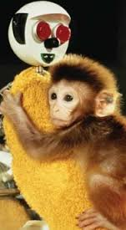
What we learned: __________________ and __________________ are vital to attachment, learning, emotional well-being, and psychological development.

What happened to the monkeys that were used in the study? How were they as adult monkeys?

What were two ethical violations?

Some baby animals experience a ____________________ early in life when certain things have to happen for ____________________________ to occur.

Define Imprinting:

Describe the “Strange Situation” Experiment by Mary Ainsworth.

Describe the three types of attachment:
- Secure
- Insecure Avoidant
- Insecure Ambivalent

Sensitive and attentive mothers usually raise ____________________ children.
Less responsive mothers who often ignored their children, or super-anxious mothers who obsessed over every little thing, often raise ______________________ children.

Young children exposed to extended abuse, trauma, and neglect, are at a higher risk for psychological disorders, health problems, and substance abuse as adults.

Children who have a positive self-concept are more happy, confident, independent, and sociable.
What is self-concept?

Describe the three types of parents:
- Authoritarian
- Permissive
- Authoritative
Which type of parenting style is the most effective at raising children with a positive self-concept?

Who is Lawrence Kohlberg?

Three Stages of Moral Development:
- Preconventional
- Conventional
- Postconventional

Well-known for the Heinz Dilemma

Psych Crash Course #20 Development – Adolescence (Module 51-53)

Define adolescence:

Adolescence is the struggle between the need to _______________ and the need to _________________.

Erick Erikson:
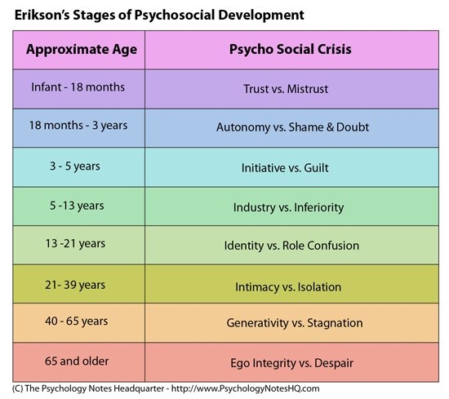

As you age, your body starts to break down. List three areas that slow down due to aging.
1.
2.
3.

What one area stays the same?

What is the difference between fluid and crystallized intelligence?

What is dementia? What causes it?

How is Alzheimer’s different?

Psych Crash Course #21: Personality Rorschach and Freudians: What makes us who we are? (Modules 55-59)

Who is Hermann Rorschach?

The point of Rorschach’s test is to determine how people ___________________ their personal
associations on to ______________________. Rorschach could then draw conclusions about a person’s ____________________.

Define Personality:

Scientists study personality by:
- Trying to understand differences in _______________________.
- Looking at how all the various parts of each person mesh together as a whole.

The Personality Perspectives:
Psychoanalytic Theory: FREUD; the unconscious
**Personality is shaped by out enduring conflict between out impulses to do whatever
we feel like, and our restraint to control these urges.

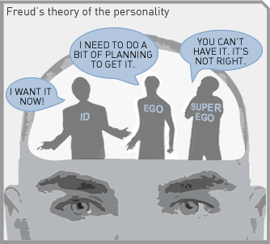
ID: EGO: SUPEREGO:

Psychoanalytic Continued…
Anxiety, according to Freud, comes from _______________________________
We deal with anxiety through defense mechanism:
- Repression

- Regression
- Reaction Formation

- Projection

- Rationalization

- Displacement

- Denial

Personality develops as we go through five stages of development:
Oral Stage

Anal Stage

Phallic Stage Fixation

Latency Stage

Genital Stage
Neo-Freudians:
Karen Horney:

Carl Jung:

Alfred Adler:
Humanistic Perspective:
Maslow and Carl Rogers

According to Maslow, what areas of the Hierarchy of Needs will develop personality?

Carl Rogers- Person Centered

Personality is defined by
Genuineness

Acceptance

Empathy

Psych Crash Course 22 - Measuring Personality (Modules 55-59)
Psych Crash Course #23 - Controversy of Intelligence- Testing and Individual Differences (Modules 60 – 64)

- What is intelligence?
- How can it be assessed?
- Is intelligence a single, general ability, or does it cover a range of aptitudes, skills, and talents?
- How do things like creativity and innovation factor in? What about genetic, environmental, and educational factors?

Define Intelligence:

Intelligence Tests:

Who is Charles Spearman?

What is the G-Factor?

What is factor analysis?

Who is LL Thurstone?

Psychometrics:

Multiple Intelligences:

What were Howard Gardner’s views on intelligence?

Savant Syndrome:
Garnder’s Multiple Intelligences (8):

What were Robert Sternberg’s thoughts on intelligence?

Describe creativity:

John Meyer and Emotional Intelligence (1990)

What is eugenics?

How do we test intelligence? Alfred Binet’s test- describe

Mental Age
IQ= ---------------- X 100
Chronological Age
What was Binet’s fear?

Who is Lewis Terman?

In what ways were IQ tests used for immigration and during WWII?

Psych Crash Course
#24 Brian v Bias

We determine intelligence related to ___________________________, __________________________,
___________________________________, and perhaps randomness itself.

What is the most widely used test to measure IQ?

These tests have 15 subtests to measure:
- Vocab
- Similarities
- Concepts
- Patterns in numbers and letters

How are achievement tests different from aptitude tests?

The three main areas tests must address:
1.

2.

3.

How are tests valid?
Predictive/ criterion validity

Construct validity

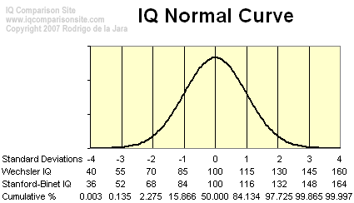

Twin and Adoptive Studies can tell us the most about intelligence. Describe the data presented.

Describe the Iranian Orphanage study of the 1970s.

**Environment and heredity interact to affect intelligence**

Explain how test bias can skew intelligence test results.

How does the stereotype threat skew test results?

Psych Crash Course #25 - Feeling all the Feels – Emotion (Modules 41- 44)
What is EMOTION?

Emotions involve _______________________, ________________________________ and conscious experience.

Emotions are made up of:
- Physiological arousal
- Expressive behaviors
- Conscious experience
Theories of Emotion:
- William James and Carl Lange : Feelings follow bodily reactions
James Lange Theory:
Give an example of this:
- Walter Cannon: too many theories are too similar
Cannon-Bard Theory:

Give an example of this

***Emotions are also tangled up with cognition***

- Stanley Schlater and Singer
Two Factor Theory:

  - Explain the SPILLOVER EFFECT:

**Cause of physiological arousal had to be identified before the person could feel and label the response as an emotion**

Arousal spurs emotion but cognition directs it
- Robert Zajonc
  - All emotions are a result of putting a name to our arousal
  - Top Down and Bottoms Up
High Road (slow process) v Low Road (instant reaction)

Review:
Sympathetic Nervous System

Parasympathetic Nervous System

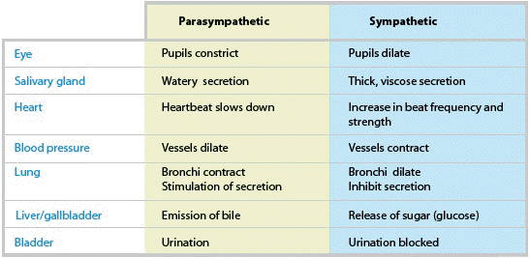

Psych Crash Course #26 - Emotion, Stress and Health (Modules 43-44)
**Our feelings and the behaviors they can drive also affect the minds, bodies, and health of those around us.**
**People with a positive outlook on life live longer.**

Paul Eckman: All facial expressions are the same across culture
Facial Feedback Theory:

Why do patients who use Botox feel happier and experience less depression?

Introverts | Extroverts

Gestures differ from culture to culture. They’re also about our ______________________ experience of what we’re thinking.

List the ten basic emotions:

What are some emotions people feel should be added?

What is the two-dimensional model?

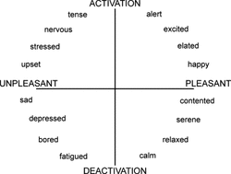
**We often overestimate the duration of our bad moods and underestimate our capacity to adapt and bounce back from traumas.**

What is stress?

Where does stress fit into? Define the categories below:
- Catastrophes
- Significant life changes
- Everyday inconveniences

Stress is ultimately good- short lived stresses can lead to focus and kick the body systems into fixing yourself like from wounds and releasing adrenaline and cortisol.
Chronic stress is bad. List some side effects of chronic stress:

Pessimism and Depression
**People characterized by their optimism, happiness, love, and positive feelings often live ______________________.
This can be explained by:
- Lifestyle or behavioral factors
- Social factors
- Biological factors
Psych Crash Course 27
Let’s Talk About Sex

Psych Crash Course - #28: Psychological Disorders – Abnormal Behavior (Modules 65-69)
What important role did Nellie Bly play in regards to hospital reform?
David Rosenhan conducted an experiment he called “On being Sane in Insane Places.” This is also one of the 40 Studies. Describe his findings.
In 2010, the World Health Organization reported that ________ million people suffer from mental or behavioral disorders.
Define what it means to have a psychological disorder:

The medical model states that psychological disorders have physiological causes that can be diagnosed on the basis of ___________________. This model is seen as being narrow and not widely used today.

The Biopsychosocial approach states that everything _______________________ is also ________________________.
This approach widely makes use of the DSM-V. Discuss that the DSM is and how it can lead to problems.

Psych Crash Course #29: OCD and Anxiety Disorders (Module 66)

Define psychological disorder:

Anxiety disorders are characterized by _____________________, _________________________ anxiety but also often by the _________________________ behaviors that reduce the anxiety.
About how many people will have an anxiety disorder?

Obsessive Compulsive Disorder:
What are obsessions?

What are compulsions?

What is Generalized Anxiety Disorder?

Describe the symptoms of a panic attack:

**A common trigger for panic disorders is simply the fear of having another attack**

How are phobias debilitating to people?
Learning Perspective  - Conditioning (stimulus generalization, reinforcement)  - Observational Learning  - Cognition | Biological Perspective  - Natural Selection  - Genetics and twin studies  - Brain chemistry (over arousal in areas of the brain that deal with impulse control and habitual behaviors)
Psych Crash Course #30: Depression and Bipolar – Mood Disorders (Module 67)
How does Kay Jamison describe bipolar disorder?

What is a mood?

What is a mood disorder?

In order to be diagnosed with a mood disorder, you must exhibit 5 or more signs for at least two weeks. What
are some of the symptoms?

Some facts about MOOD DISORDERS:
- Depression is known as the common cold of psychological disorders.
- The cause of mood disorders is often a combination of biological, genetic, psychological, and environmental factors.
- Women tend to seek treatment more often.
- A brain in a ____________ state slows down, while a brain in a _________ state speeds up.

Neurotransmitter activity:
Norepinephrine
Serotonin
Social Cognitive View:
Internal Lens: How can you break the cycle of depression?

Psych Crash Course #32: Schizophrenia and Dissociative Disorders (Module 68)
What is schizophrenia?

How many people are affected with this?

When does schizophrenia strike in men and women?

Schizophrenic spectrum:
- Loss of Contact with ________________________
- Psychotic Symptoms
- Disorganized __________________________ and _________________________
- Breakdown in selective attention
- Delusions of _________________________ not based in reality
- Narratives of ________________________ and __________________________
- Perceptual disturbances and ________________________
- Disorganized, ________________________, incongruent behavior and emotions

- Positive Symptoms:
- Negative Symptoms:
- Disorganized Symptoms:

Brain Abnormalities:
Extra dopamine receptors:

Extra activity in the thalamus and amygdala

Diathesis-Stress Model:
A combination of biological and genetic vulnerabilities- (__________________) and environmental stressors
(______________________) that contribute to the onset of schizophrenia.
- Genetic Vulnerability
- Poverty

Dissociative Disorders (RARE)
What is the difference between amnesia and identity disorders?

Psych Crash Course #33: Eating and Body Dysmorphic Disorders – Other (Module 69)

Today in the US, an estimated ___________________________ women and ___________________ men have suffered
from a clinically significant eating disorder at some point in their lives.

Types of Eating Disorders:
- Anorexia
- Bulimia
- Bing-eating disorders

What are the side effects of an eating disorder?

Explain why people have an eating disorder?

**Most commonly found in white women in western countries**

Body Dysmorphic Disorder (BDD):
Signs of BDD:

How do body dysmorphic disorders come about?
- Serotonin and Dopamine
- Genetics
- Environmental factors
- Learning by observation

Psych Crash Course - #34: Personality Disorders – Other (Module 69)

Ego-Dystonic | Ego- Syntonic

There are ten distinct personality disorders:
A | B | C
Paranoid  Schizoid  Schizotypal | Antisocial  Borderline  Histrionic  Narcissistic | Avoidant  Dependent  Obsessive-Compulsive
Odd  Eccentric behavior | Emotional  Impulsive | Anxious  Fearful  Dependent

****Most diagnosed with personality disorders are diagnosed with PDNOS (Personality Disorder not Otherwise Specified)
Define borderline personality disorder:

What is antisocial personality disorder

Dimensional Model: 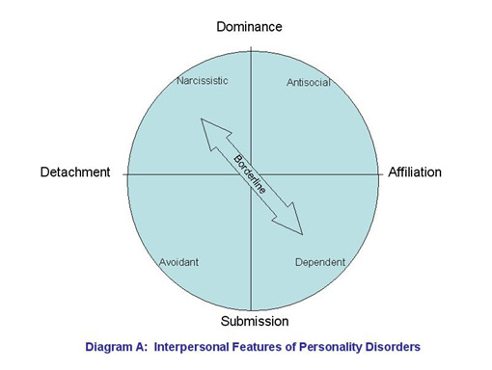Causes:
Psych Crash Course # 35: Psychotherapy: Getting Help Treatment (Modules 70-73)

Define Psychotherapy:

List the types of therapies:
1.
Freud: Looked at mostly ___________________ feelings.
__________________ thoughts
__________________ association and dream analysis
Interpretations and self-insight

2.
Jung, Adler, and __________________
__________________ internal forces
Focused on the ________________ relationships and critical childhood
experiences
3.
Carl Rogers
People inherent capacity for making rational choices achieving self-acceptance,
attaining maximum potential
Insight orientated and refer to the patients as _______________
Client-Centered Therapy:
- Safe, ___________________ place
- Self-Acceptance
- _______________________________
- Self- ___________________________
  - Maximize potential
  - Meaning in life
  - Overcome fears

4.
Pavlov, _________________, Skinner
**Problem behaviors as the issue, elimination of unwanted behavior, replacement functional
behavior, new learning and conditioning**
Counterconditioning:

Exposure Therapies:

Systematic Desensitation:

Aversive Conditioning:

5.
Aaron Beck
Socratic Questioning

Murphy’s Law

**Changing what we say to ourselves is a very effective way to _____________ with our
anxieties and ______________ our behavior.

**It is a thought that counts**

Utilize _________________ therapies and _________________ therapies

Psych Crash Course # 36 Biomedical Approach to Therapy (Module 73)

What are some examples of biomedical treatment approaches?

How do psychologists know if their therapy methods are successful:
1.
**89% of clients said they were “fairly satisfied” with their treatment**

2.
Self-serving bias:

Treatment outcome standard:

Randomized Clinical Trial (RCT):

Meta Analysis:
Effectiveness

Efficacy

3.
Hope, new perspective, genuine empathy, trusting and caring relationship, clear and positive
communication

Define biomedical therapy:

Pharmacotherapy:
- Antipsychotics
- Anxiolytics
- Antidepressants Combined with psychotherapy this can be
- Mood stabilizers the most successful treatment

Electroshock therapy:
- Treatment of severe depression
- Theories:

**One of the most effective methods of dealing with mood disorders is a life style change. _______________ minutes of physical activity can be as effective as an antidepressant. Combine with __________________, social _________________, and ______________ nutrition there is great hope for people suffering with mood disorders.

Psych Crash Course #37: Social Thinking (Social Psychology Modules 74-80)

What is social psychology?

Social Thinking:

Personality v Situation

What is the Attribution Theory?

What is the Fundamental Attribution Error?

_____ in 10 women report that men have misread their polite friendliness—which would be appropriate for the situation—as a sexual-come on.

Petty and Cacioppo Study:
Central Route Persuasion:

**When _______________ people focus on the ______________ and ________________ at hand, and are persuaded by the actual content of the message**

Peripheral Route Persuasion:

**Happens when you are not paying 100% attention**

Foot-in-the-door phenomenon:

Describe the Zimbardo Prison Experiment (1971)

**The power of a given situation can easily override individual differences in personality**

Leon Festinger’s Theory of Cognitive Dissonance:

**The point is that this mismatch between what we do and who we think we are induces
tension—COGNITIVE DISSONANCE—and that we tend to want to remove the tension.

Psych Crash Course #38: Social Influence (Module 75)

Describe the Stanly Milgram Yale University 1960 Obedience Study:

What were the results of the Milgram Obedience Study?
- How many participants delivered the maximum 450 volt shock?

- How many participants delivered a 300 volt shock?

- Obedience was highest when the person giving the orders was _______________ and was perceived as an _____________________________, especially if they were from a ____________________ institution.

Social Influence:
Solomon Asch Study:

People tend to conform if they are:
- Made to feel ______________________
- In a group of ______________________
- People ___________________________
- __________________ the group
- Feel others are ____________________

**Milgram and Asch underscore the __________________ of the situation in conformity—whether that situation elicits ______________________ for authority, fear of being ____________________, fear of ______________________, or simply a desire for ________________________.
Social Facilitation:

What happens when people are blindfolded and they are playing tug of war?

Social Loafing:

Deindividuation:

Riots, trolling- the less ______________________ we feel, the more we’re at the
____________________ of the experience of our group whether it is _____________ or ____________

Group Polarization:

Group Think:

**Group behavior is powerful, but so is individual choice**

Psych Crash Course #39: Prejudice and Discrimination (Module 77)

Implicit Bias:
- How we relate to each other
- What factors cause us to _________ another person, or ____________ them, or _________ them.
- What are the social, cognitive, and emotional roots of prejudice, racism, and sexism, and how do they shape society?

Define prejudice:

Examples of prejudices: gender, ethnic, socioeconomic status, and culture

Define Stereotype:

**When ____________________________ beliefs combine with prejudicial attitudes and
emotions, like ____________ and hostility, they drive discrimination**

Remember: prejudice= attitude
Discrimination = behavior

Dual Process Theory:

Implicit Association Test (IAT):

Why do prejudices exist?
- Justify social inequalities:
  - People get what they deserve and deserve what they get
  - Just World Phenomenon
- Us v Them mentality
  - In Group/ Out Group Bias

Psych Crash Course #40: Aggression v Altruism: The Psychology of War and Peace (Modules 78 & 80)

Describe the Robber’s Cave Study:

Results of Robber’s Cave:
- People can overcome differences and settle conflicts

Define aggression:

Examples: verbal, physical, and __________________
Where does aggression come from?
**combination of _________________ factors- like genetics, neurological, and
biochemical influences—and our ____________________ and ___________________

Frustration- Aggression Hypothesis:

Altruism
John Darley and Bibb Latane: 1960s experiment:

Bystander Effect:

Determining if someone is going to be involved with an incident is determined by a cost benefit analysis.
Example: return a wallet for a reward, do a job for recognition

Social Exchange Theory:

**We act altruistically because we expect that the people we help with go on to help others**

Reciprocity Norm:

Social Responsibility Norm:

Conflict:

Social Trap:

**Self-interest=conflict**

