Download the Schoology App –
2. Type in “Wcskids”
3. Select “Warren Consolidated Schools”
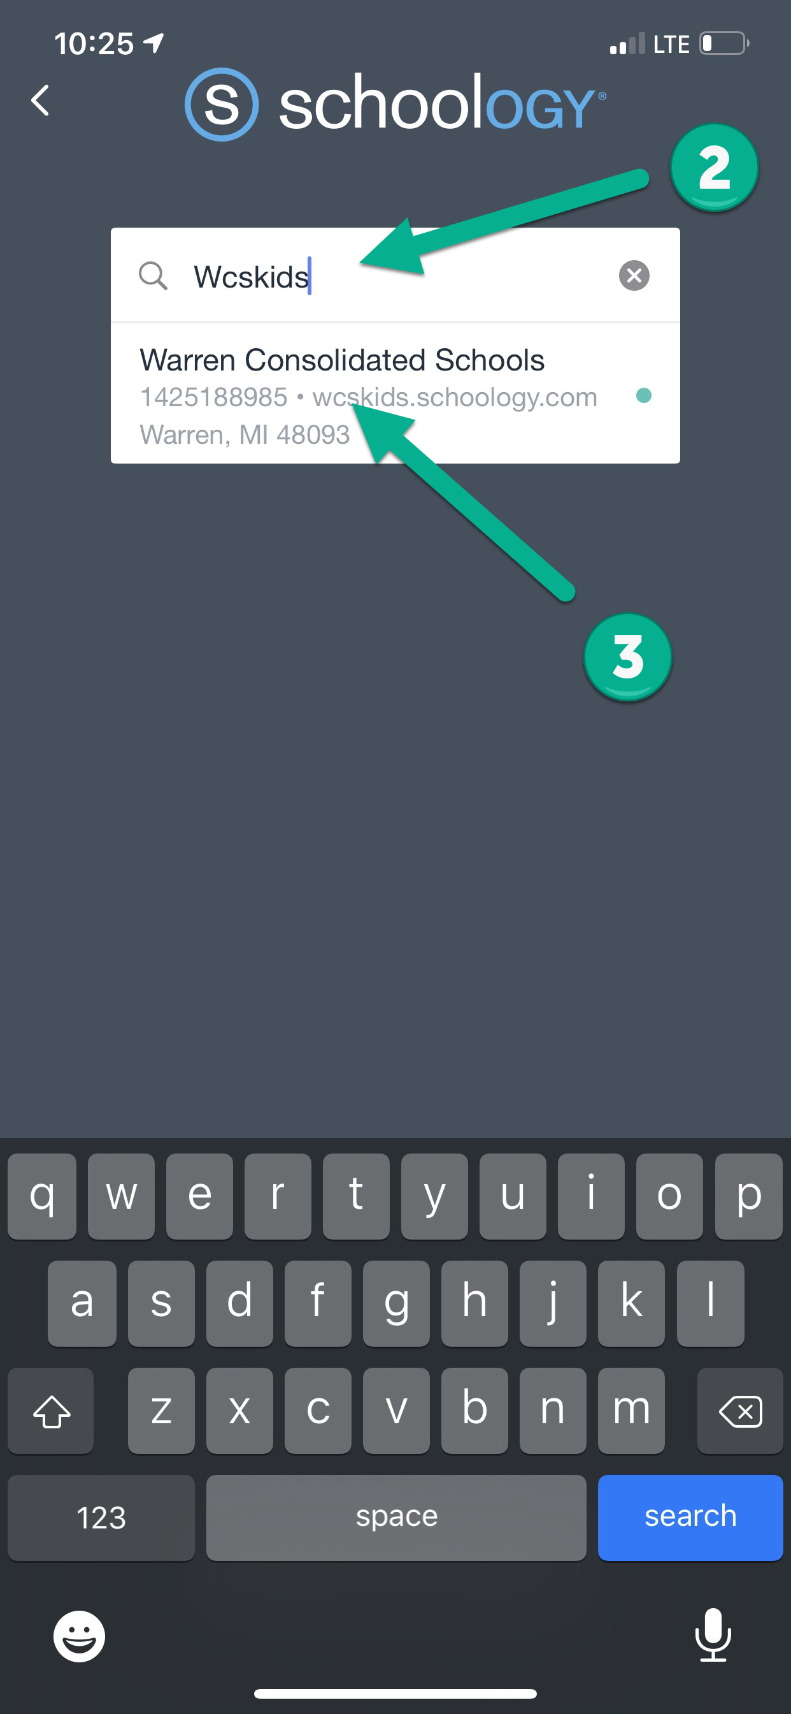
1. Click on “Find your school or domain”
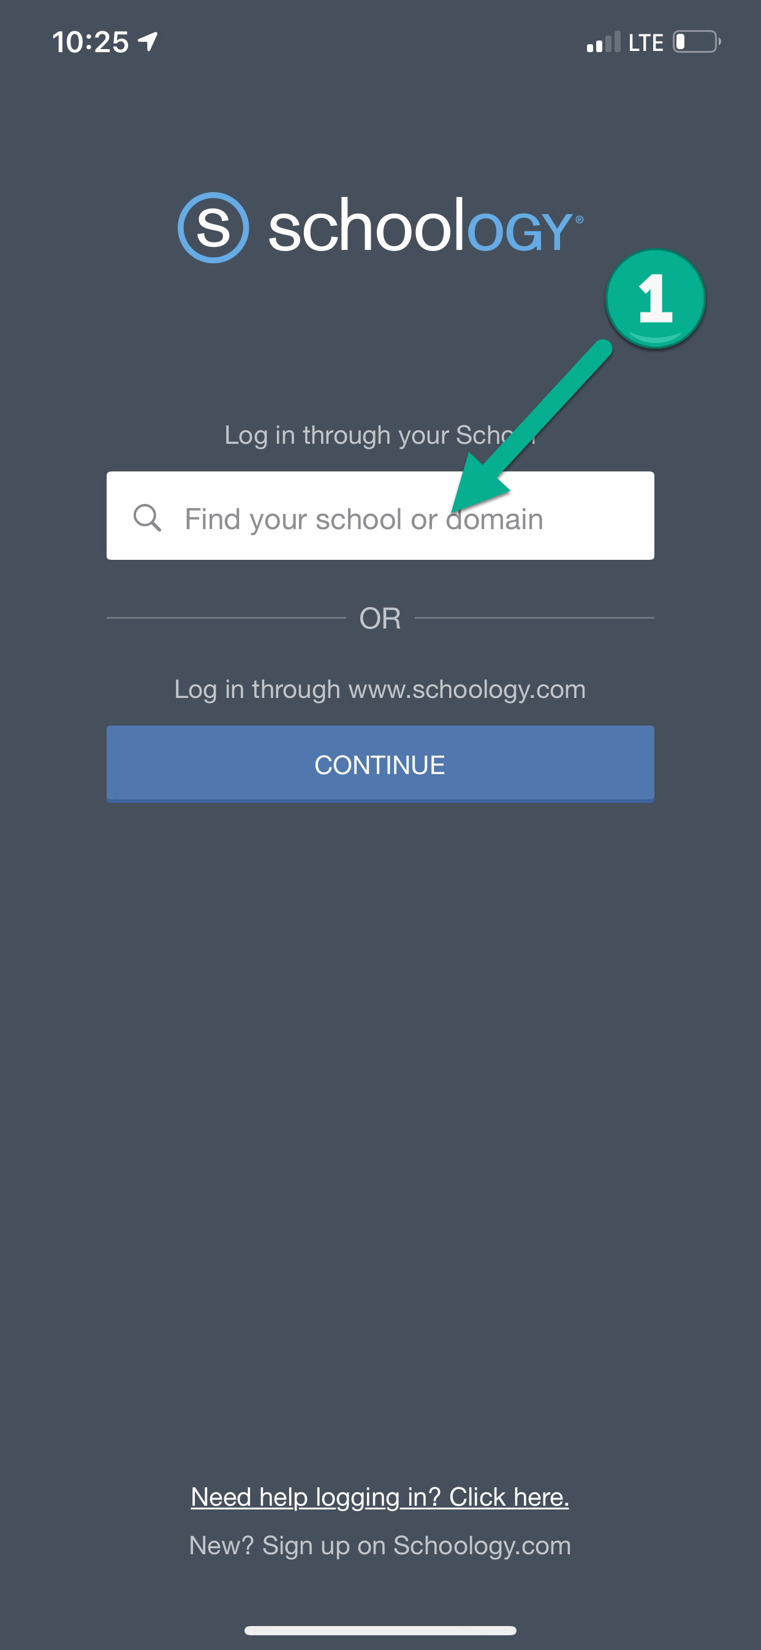

4. Type in your student ID number followed by @wcskids.net (ex. 123456@wcskids.net)
5. Select “Next”
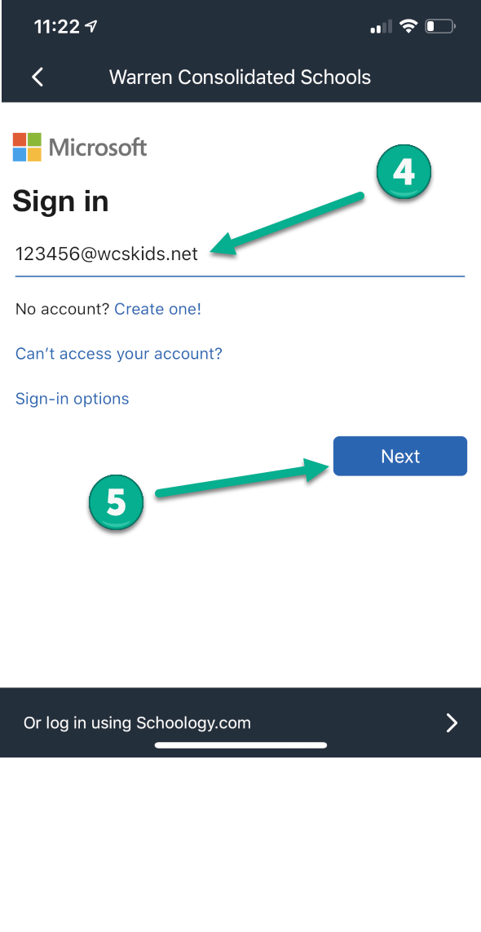
6. Enter your district-provided password in all CAPS (ex ABC123)
7. Select “Sign In”
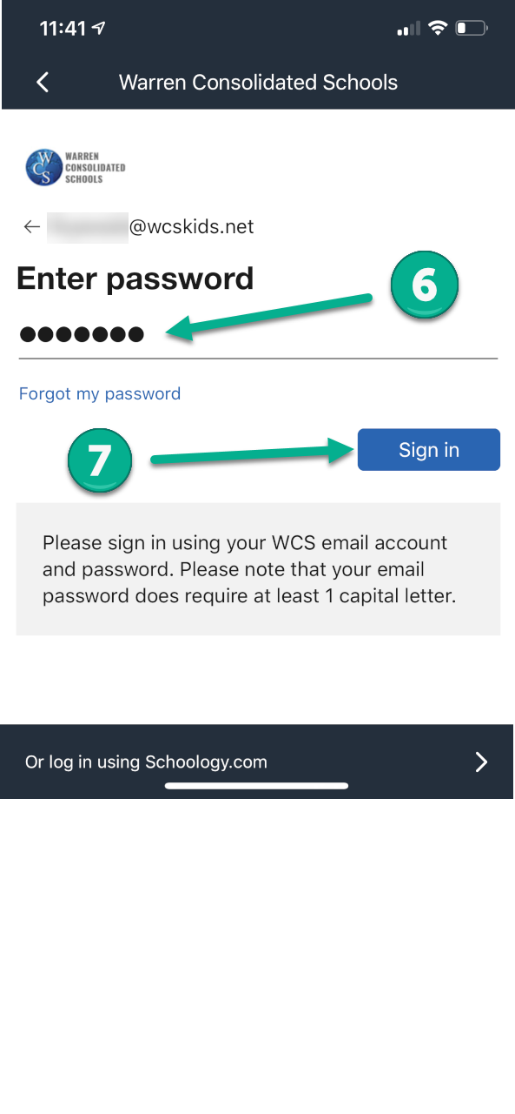

11. Select the “Menu” for more options
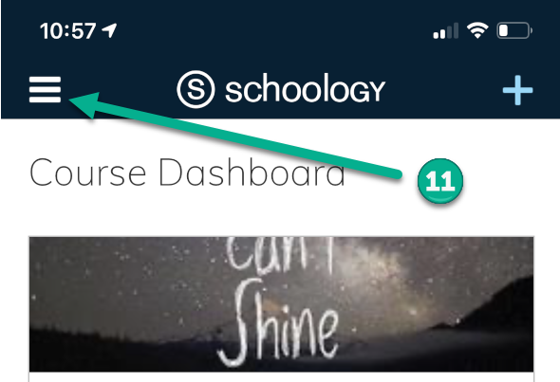
12. Send or Receive “Messages”
13. Check to see if you have any “Notifications”
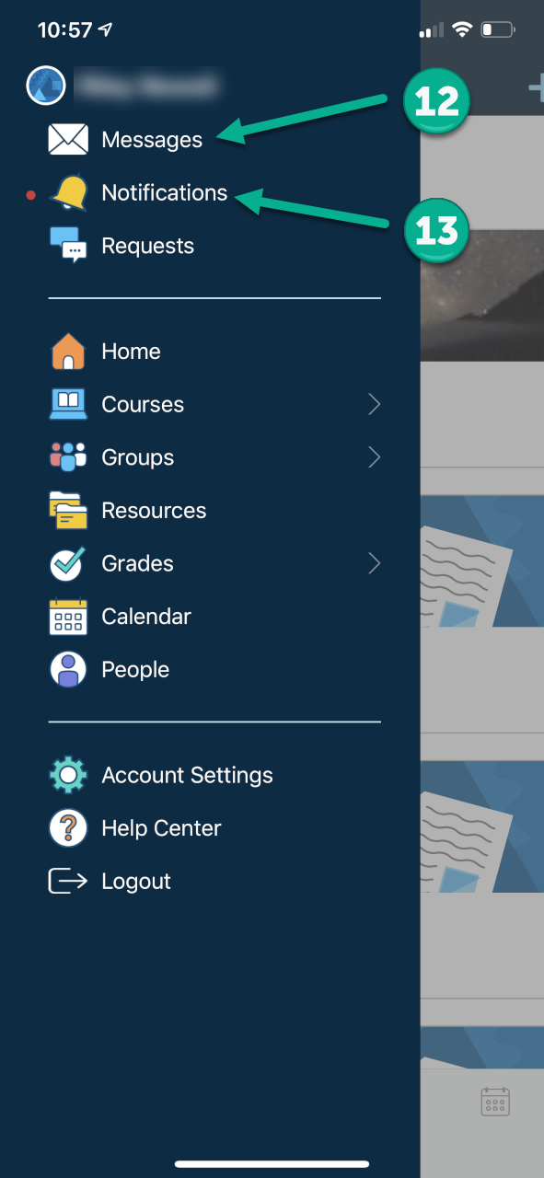

This will take you to your Schoology Dashboard. From the dashboard you can:
8. Enter a “Course”
9. View “Recent Activity”
10. Look at “Calendar” to see upcoming events
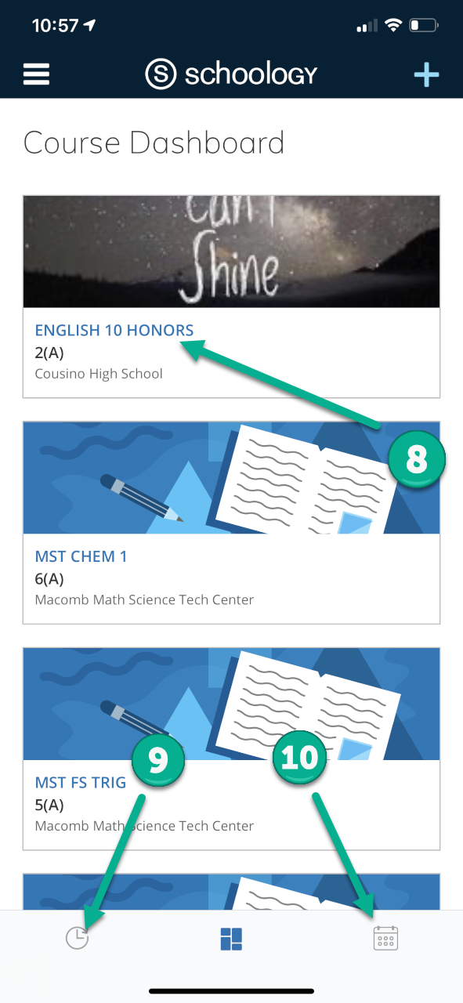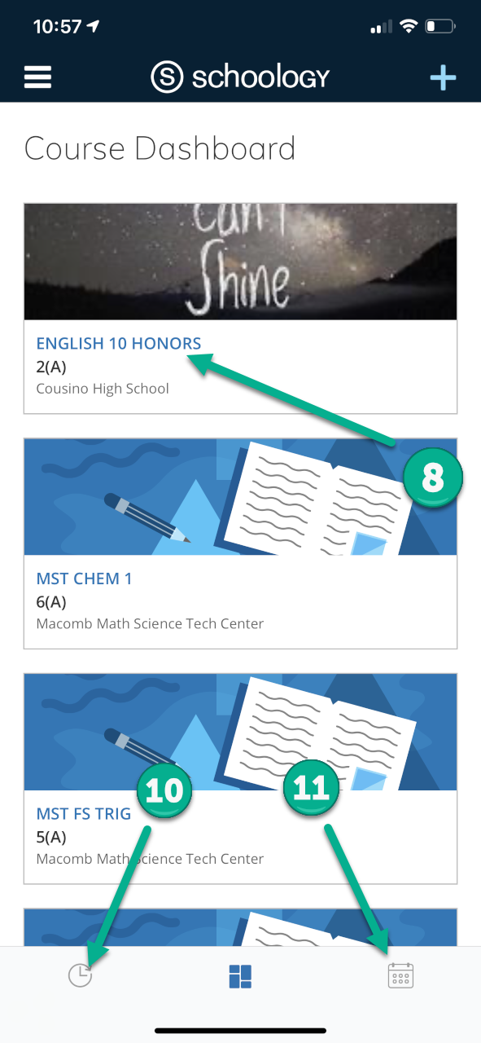

App Icons
Folder – Select to see contents
Assignment – Select to see directions and complete
Assessment – Select to complete Assessment
Discussion – Select to participate in Discussion
Link – Select link and you will be directed to content

File – Select to view attached file

For additional support, visit - https://support.schoology.com/hc/en-us/articles/360011805394-iOS-Mobile-App-Students-

Forgot your password?

Go to https://www.wcs.k12.mi.us/documentdepot/se/forms/27/Lookup.aspx and fill in the following fields:

- Student ID # - 6 digits.
- Your house number – just the numbers of your home address.
- Student Date of Birth – must be in mm/dd/yyyy format (ex.12/31/2020).

